PATUAKHALI SCIENCE AND TECHNOLOGY UNIVERSITY



**Assignment Name: Lab Problem 02**

**Course Code: CCE-314**

**Course Title: Computer Networks Sessional**

Submitted by:

**Arfan Ahmed**

ID No.: 2002040

Registration No.: 09557

Level-3, Semester-1, Session: 2020-2021

Faculty of Computer Science & Engineering

Submitted to:

**Dr. Md. Samsuzzaman**

Professor

Department of Computer and Communication Engineering

Faculty of Computer Science and Engineering

Date of Submission: April 27, 2023

Lab 2.6.1: Topology Orientation and Building a Small Network

# Topology Diagram

***Peer to Peer Network***

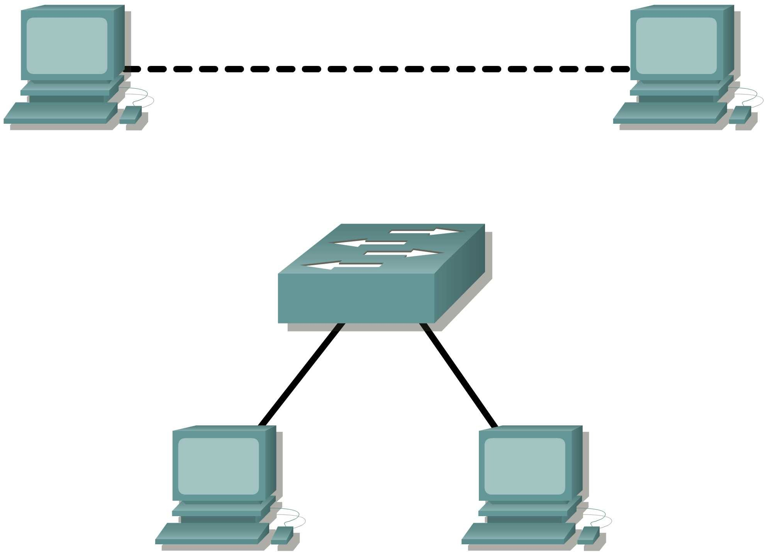

***Switched Network***

# Learning Objectives

Upon completion of this lab, you will be able to:

* Correctly identify cables for use in the network.
* Physically cable a peer-to-peer and switched network.
* Verify basic connectivity on each network.

# Background

Many network problems can be fixed at the Physical layer of a network. For this reason, it is important to have a clear understanding of which cables to use for your network connections.

At the Physical layer (Layer 1) of the OSI model, end devices must be connected by media (cables). The type of media required depends on the type of device being connected. In the basic portion of this lab, straight–through or patch—cables will be used to connect workstations and switches.

In addition, two or more devices communicate through an address. The Network layer (Layer 3) requires a unique address (also known as a logical address or IP Addresses), which allows the data to reach the appropriate destination device.

Addressing for this lab will be applied to the workstations and will be used to enable communication between the devices.

# Scenario

This lab starts with the simplest form of networking (peer-to-peer) and ends with the lab connecting through a switch.

## Task 1: Create a Peer-to-Peer Network.

### Step 1: Select a lab partner.

**Step 2: Obtain equipment and resources for the lab.**

Equipment needed: 2 workstations

2 straight through (patch) cables 1 crossover cable

1 switch (or hub)

## Task 2: Identify the Cables used in a Network.

Before the devices can be cabled, you will need to identify the types of media you will be using. The cables used in this lab are crossover and straight-through.

Use a **crossover cable** to connect two workstations to each other through their NIC’s Ethernet port. This is an Ethernet cable. When you look at the plug you will notice that the orange and green wires are in opposite positions on each end of the cable.

Use a **straight-through cable** to connect the router’s Ethernet port to a switch port or a workstation to a switch port. This is also an Ethernet cable. When you look at the plug you will notice that both ends of the cable are exactly the same in each pin position.

## Task 3: Cable the Peer-to-peer Network.

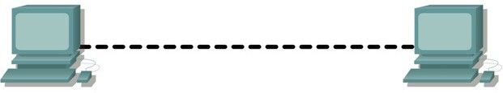

### Step 1: Connect two workstations.

Using the correct Ethernet cable, connect two workstations together. Connect one end of the cable to the NIC port on PC1 and the other end of the cable to PC2.

Which cable did you use? **Copper Cross-Over**

### Step 2: Apply a Layer 3 address to the workstations.

To complete this task, you will need to follow the step-by-step instructions below.

**Note:** These steps must be completed on *each* workstation. The instructions are for Windows XP—steps may differ slightly if you are using a different operating system.

1. On your computer, click **Start**, right-click **My Network Places**, and then click **Properties.** The Network Connections window should appear, with icons showing the different network connections.

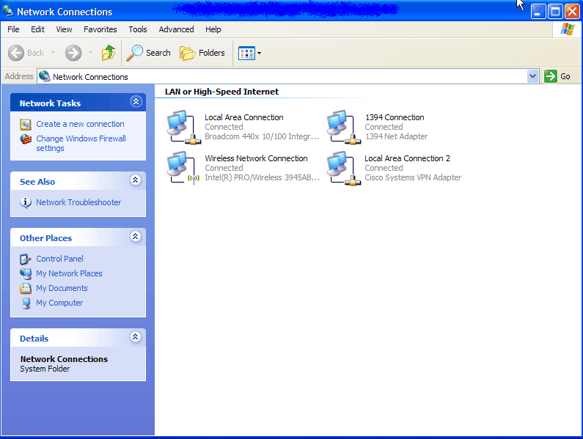

1. Right-click the **Local Area Connection** and click **Properties**.
2. Select the **Internet Protocol (TCP/IP)** item and then click the **Properties** button.

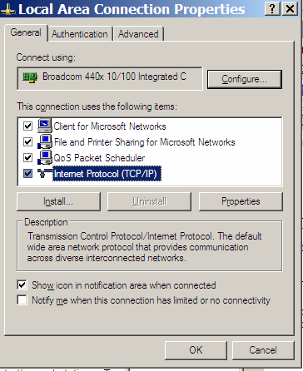

1. On the General tab of the Internet Protocol (TCP/IP) Properties window, select the **Use the following IP address** option.
2. In the **IP address** box, enter the IP address 192.168.1.2 for PC1. (Enter the IP address 192.168.1.3 for PC2.)
3. Press the tab key and the Subnet mask is automatically entered. The subnet address should be 255.255.255.0. If this address is not automatically entered, enter this address manually.
4. Click **OK**.

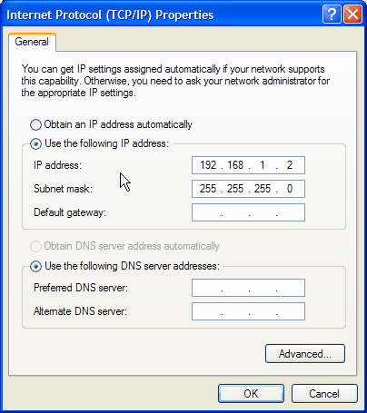

1. Close the Local Area Connection Properties window.

### Step 3: Verify connectivity.

1. On your computer, click **Start**, and then click **Run**.

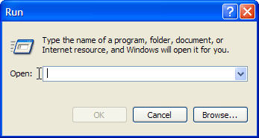

1. Type **cmd** in the Open box and then click **OK**.

The DOS command (cmd.exe) window will appear. You can enter DOS commands using this window. For the purposes of this lab, basic network commands will be entered to allow you to test you computer connections.

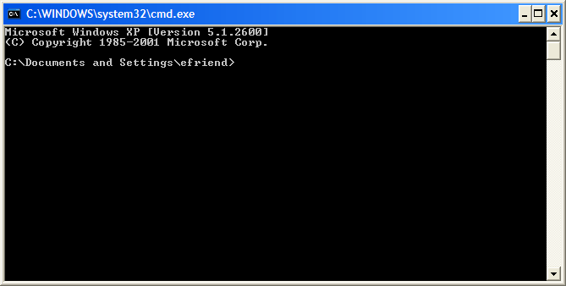

The **ping** command is a computer network tool used to test whether a host (workstation, router, server, etc.) is reachable across an IP network.

1. Use the **ping** command to verify that PC1 can reach PC2 and PC2 can reach PC1. From the PC1 DOS command prompt, type **ping 192.168.1.3**. From the PC2 DOS command prompt, type **ping 192.168.1.2**.

What is the output of the **ping** command?

Pinging 192.168.1.3 with 32 bytes of data:

Reply from 192.168.1.3: bytes=32 time<1ms TTL=128

Reply from 192.168.1.3: bytes=32 time<1ms TTL=128

Reply from 192.168.1.3: bytes=32 time<1ms TTL=128

Reply from 192.168.1.3: bytes=32 time<1ms TTL=128

Ping statistics for 192.168.1.3:

Packets: Sent = 4, Received = 4, Lost = 0 (0% loss),

Approximate round trip times in milli-seconds:

Minimum = 0ms, Maximum = 0ms, Average = 0ms

If the **ping** command displays an error message or doesn’t receive a reply from the other workstation, troubleshoot as necessary. Possible areas to troubleshoot include:

* + Verifying the correct IP addresses on both workstations
  + Ensuring that the correct type of cable is used between the workstations

What is the output of the **ping** command if you unplug the network cable and ping the other workstation?

Pinging 192.168.1.3 with 32 bytes of data:

Request timed out.

## Task 4: Connect Your Workstations to the Classroom Lab Switch.

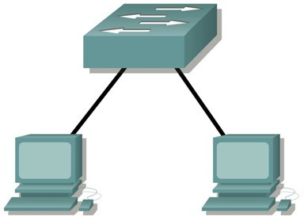

### Step 1: Connect workstation to switch.

Using the correct cable, connect one end of the cable to the NIC port on the workstation and the other end to a port on the switch.

### Step 2: Repeat this process for each workstation on your network.

Which cable did you use? **Copper Straight-Through**

### Step 3: Verify connectivity.

Verify network connectivity by using the **ping** command to reach the other workstations attached to the switch.

What is the output of the **ping** command?

Pinging 192.168.1.3 with 32 bytes of data:

Reply from 192.168.1.3: bytes=32 time<1ms TTL=128

Reply from 192.168.1.3: bytes=32 time<1ms TTL=128

Reply from 192.168.1.3: bytes=32 time<1ms TTL=128

Reply from 192.168.1.3: bytes=32 time<1ms TTL=128

Ping statistics for 192.168.1.3:

Packets: Sent = 4, Received = 4, Lost = 0 (0% loss),

Approximate round trip times in milli-seconds:

Minimum = 0ms, Maximum = 0ms, Average = 0ms

What is the output of the **ping** command if you ping an address that is not connected to this network?

Pinging 192.168.1.3 with 32 bytes of data:

Request timed out.

### Step 4: Share a document between PCs.

1. On your desktop, create a new folder and name it **test**.
2. Right-click the folder and click File sharing. **Note:** A hand will be placed under the icon.
3. Place a file in the folder.
4. On the desktop, double-click **My Network Places** and then **Computers Near Me**.
5. Double-click the workstation icon. The **test** folder should appear. You will be able to access this folder across the network. Once you can see it and work with the file, you have access through all 7 layers of the OSI model.

## Task 5: Reflection

What could prevent a ping from being sent between the workstations when they are directly connected?

1. Network Configuration
2. Firewall Settings
3. Network Adapter Settings

etc.

What could prevent the ping from being sent to the workstations when they are connected through the switch?

1. Incorrect IP Configuration
2. Switch Configuration
3. Physical Connectivity Issues
4. Network Interface Settings
5. Network Firewall or Security Settings

etc.